Hello Parents and Students,
Welcome to the fourth grade! We have a year packed full of fun and can’t wait to get started! Below you will find important information about your class. We will be calling you very soon for a brief welcome and question time.

Class Schedule
We will be putting heavy emphasis on differentiating our instruction to meet the specific needs of each fourth-grade student. You will see there are multiple classes scheduled to run from 9:00 AM until 2:30 PM. Your child will not be required to attend the full duration of that time but may have multiple 30-45-minute classes scheduled within that time frame. Please understand that our groupings are flexible and may change as your child shows growth or need. This means that his/her schedule for small group sessions can change every eight weeks depending on need shown by data. Each student will have their own unique class attendance plan, and high priority should be set on your child attending each class listed on his/her daily plan. Attendance in classes listed on daily plans are NOT optional. We appreciate your cooperation in assuring that students log to each class on and on time.

Pathways
Parents, please make sure you understand which pathway your child has been placed upon- Independent, Virtual, or Blended. Like our grouping in our Virtual classes, blended classes are flexible and may change as well depending on the academics of each student. Please see the pathways requirements below to ensure you understand daily duties your child will have this year. Please note that pathway assignments are based upon student data. These assignments will not be changed by administration unless there is sufficient data to support a requested change by the parent.
Pathway Requirements/Work Submission
Your student should make 3% gains each week in the OLS. To ensure that proper progress is being made follow your daily plan for all course subjects. Additional work may be assigned in live classes, depending on the class.
Below is an outline of the frequency of courses in the OLS:

OLS

- Every day you will log into your OLS and follow your Daily Plan.
- The fourth grade courses are as follows:
  - Music (2 x per week)
  - GUM (3 x per week)
  - Vocabulary (5 x per week)
  - History (3 x per week)
  - Science (2 x per week)
  - Social Studies (2 x per week)
  - State History (1 x per week). This course will not be on your plan until October. Make sure you choose “Nevada” as your state.
  - Math Plus Red- See Calendar
  - Literature 4- See Calendar
  - Composition- See Calendar
- There are online and off line components to OLS work. Please make sure that students are completing bookwork when it is assigned from the daily lesson. The teacher may periodically request sample bookwork and/or unit exams.

Optional Lessons: While these lessons are not required, they will not remove themselves from daily plans and will keep you from progressing. If there is an optional lesson that appears it is very important that you complete the lesson or mark the lesson complete. If you do not do one of the two, the same lesson will repeatedly present on your plan and your progress will decline.
Missed Lessons:
If you miss a lesson, you must go into the subject area and complete the lesson as it will not automatically move to the next day for you. Please see photos below to illustrate how to find lessons outside of your daily plan.
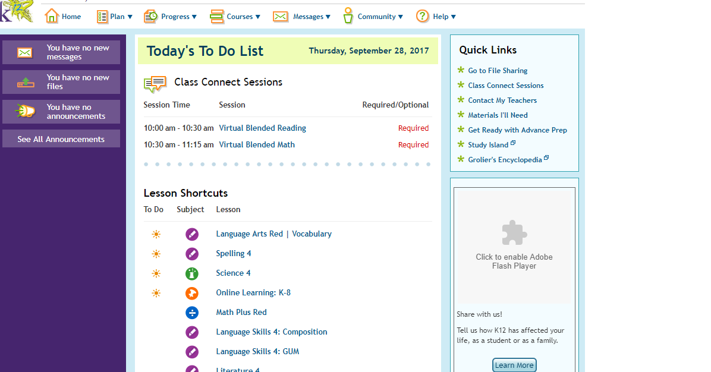

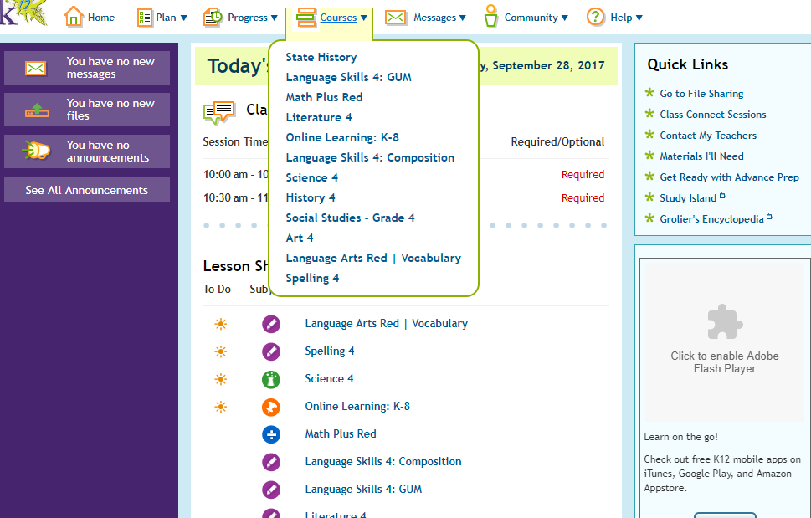

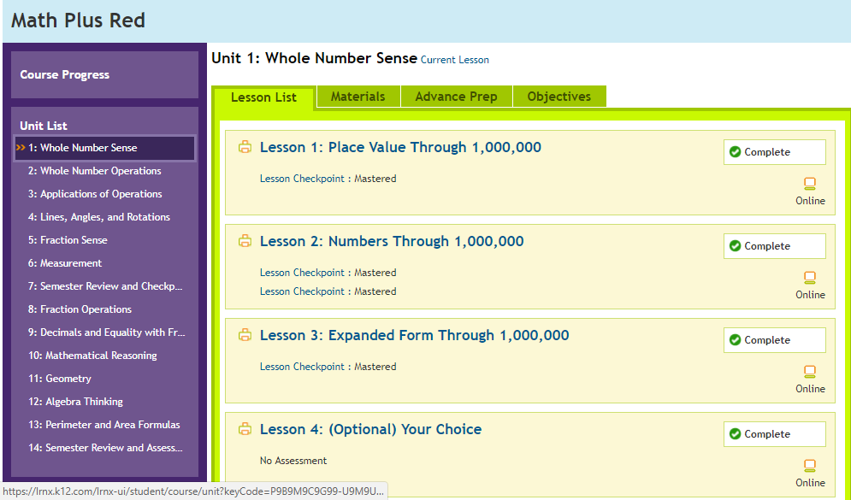
Chose the unit that you need to complete
And assignment in
Chose the lesson that you need to complete

Calendar Literature 4 and Math Plus Red (Blended and Virtual Pathways)
There will be an updated calendar on our website to help you track the lessons you should be completing in Math Plus Red and Literature 4. Please check our website for our August calendar!
OLS Grading (ALL Pathways)
- You are required to make 2.5-3% progress in EVERY course EVERY week.
- Your teacher and/or academic advisor may contact you regarding your progress.
Grades from coursework on the daily plan are calculated by the expected progress vs. actual progress. As stated, teachers will update students on expected progress, but a general guideline is:
25% complete by Quarter 1
50% complete by Quarter 2
75% complete by Quarter 3
100% complete by Quarter 4
Work Submission
Students will have specific turn in dates for assignments given in the OLS and through live classes. Work will not be accepted outside of the turn in window. We do understand that certain circumstances do happen from time to time. Please contact your child’s teacher immediately should you foresee a problem with promptness in work submission. Late assignments will be docked 20%.

If missing assignments begin to affect your student’s grades, the following procedures will take place:
- Conference with Teacher
- Utilization of school FAST team to get student on track
- Administration intervention

Weebly/Class Website
Our class website is listed below. We update the website weekly and students, as well as parents, should be visiting the page frequently. There are many valuable resources and messages posted on the page, and we STRONGLY encourage you to get familiar with the website.
www.teamfourthgradenvva.weebly.com

Academic Integrity – Please review Nevada Virtual Academy’s policy on plagiarism.
  - Nevada Virtual Academy holds students accountable for doing their own work. Students who submit work as their own when it is not wholly and completely their own are guilty of cheating and/or plagiarism. Plagiarism is the deliberate representation of another’s words, thoughts, or ideas as one’s own without attribution in connection with submission of academic work, whether graded or otherwise. Cheating can be defined as claiming credit for any assignment or assessment without putting forth the academic effort required for the assignment or assessment. Assisting other students in cheating or plagiarism is also considered academic dishonesty. This includes a child logging in using the parent/Learning Coach account.
  - Here are some clear examples of what can be considered plagiarism and cheating:
  - Having a friend or parent help you on a test, even if the friend/parent just explains words or questions to you.
  - Copying the words of another source (person or print) without putting those words in quotation marks.
  - Using the ideas of another source without giving credit to the source, even if you are using your own words.
  - Using books, websites, smartphones, notes, or assistance from other people on tests or quizzes unless your teacher has specifically stated outside material may be used.
  - Copying your assignments/tests (in part or in whole) and posting them on help websites like Yahoo Answers or Wiki Answers for assistance with the assignment.
  - Talking with others (family, friends, acquaintances, online help sites, etc.) during a test.
  - Using the Parent/Learning Coach account
After an initial warning and explanation by the teacher, students who are guilty of cheating or plagiarizing will be referred to school administration for breach of the school’s Academic Integrity Policy and the school’s Progressive Discipline Plan will be followed.

Your child must submit his/her own work both virtually and on the OLS. Parents should act as learning coaches and guide students throughout lessons, but should not give students direct answers. Marking off OLS lessons is considered cheating. An average OLS lesson should take anywhere from 30 minutes to an hour.

Teachers monitor OLS progress daily and should an unreasonable amount of lessons show completed in one day, teachers will contact parents and may request offline bookwork for each completed lesson to be submitted. If there is negligence to Nevada Virtual Academy’s Academic Integrity policy, the following actions will be taken:

- Conference with teacher to answer any questions or clear misconceptions. This may include requesting written book work for lessons completed
- Phone conference with school counselor/advisor.
- Administration Intervention- Parents may be mandated to attend a meeting in person with administration.
Student Microphones
It is essential for your child’s success in the virtual classroom to have a working microphone. Please ensure that your child has a microphone and that it is functioning properly at all times. If you have any problems obtaining a microphone, please contact your child’s homeroom teacher.
Throughout our virtual class lessons, we regularly open student microphones. We also open microphones while students are working with their peers in breakout rooms. It is so important for your student to have the opportunity to come on the microphone to share their thoughts, ask and answer questions, and interact with their peers.
While we understand that due to the nature of our class setting, from time to time we will pick up on background noises and conversations. While we understand that this may happen, we want to remind you that we have a zero tolerance for background noise/conversations that includes any profanity. If profanity is heard from a learning coach or a student, the following actions will be taken:
First Time: You will be reminded of our classroom policies and your child may not be able to use his/her microphone for the remainder of the class.
After The First Time: Your child will be removed from the class session and Administration will be notified.
We appreciate your cooperation with this matter as we want to provide the best learning environment for all of our students every day. If you have any questions, please reach out to your homeroom teacher.

Attendance
Virtual and Blended students are required to attend all Virtual Class Connect sessions listed on their plans. Blended students are additionally required to attend face-to-face classes every Wednesday afternoon from 12:30-3:30 at the Sandhill NVVA location. If your child is absent, it is required to:
1) Email an excuse note to your homeroom teacher.
2) Student must watch the recording of the lesson missed.
3) Student must send a detailed summary of what he/she learned in the lesson and send any exit tickets and/or assignments to their homeroom teacher.
Multiple absences will result in:
1) Conference with teacher
2) Support offering from FAST team
3) Administration intervention
Failure to log onto your OLS for 10 consecutive days puts student at risk of removal from NVVA’s program. If there are more than 20 absences, the student is put at risk of retention. There is a lot of information covered every day and every minute is accounted for. Please make sure your child is logging in for ELA, Math, and Small Groups daily.
OLS Attendance- Parents, please make sure you are accurately entering attendance on the OLS platform for OLS coursework, daily.
Tardies
Please make sure your child is arriving to virtual class on time. We understand that from time to time there are technical issues that prevent a student from logging into class on time. To prevent technical issues from interfering with punctuality, we encourage students to sign into class connect sessions a few moments early. If you are having technical issues logging in, please email me to let me know and/or contract technical support.
*Unless previously discussed with the teacher, students who log in 15 minutes late will be marked tardy. Students who log in later than 15 minutes from the start time will be marked as absent. Multiple tardies will be followed up on as follows.
1) Conference with teacher
2) Support offering from FAST team
3) Administration intervention

Classroom Policies
- Behavior
  - Positive Reinforcement
Positive reinforcement is the driving force of our classroom. We work hard to build a community of learners who thrive in a respectful and positive learning environment.

  - Correcting Undesired Behavior
Students who fail to follow classroom norm will be redirected with the following steps:
- First Offense- Warning
- Second Offense-Visit to a refocus room where student will complete a redirection slide and conference with teacher. Visitation to the refocus room will be documented and parent will receive a copy of the completed refocus slide.
- Third Offense-Phone Call Home
- Fourth Offense- Administration Intervention

Participation
Students must come to class ready to participate and remain involved in the lesson throughout the class. If teachers do not get a response from students, after 3 tries, the student will be placed in the MIA room. They will remain in the room until they notify the teacher that they are back by giving a green check.

A teacher will conference with the student and document the visit. If the student does not respond back to the teacher within the class period, the student will be marked absent. If multiple occurrences to the MIA room occur, intervention to support the student will take place in the following order
- Conference with teacher
- Utilization of school FAST team to get student on track
- Administration intervention

What We Will Be Learning This Year
If you would like to get a sneak peek at the fourth grade standards, please visit: http://www.doe.nv.gov.
You can also visit our class website throughout the year to keep track of our current studies.
We will test our learning by completing the mandatory SBAC and ACT Aspire end-of-the-year state tests. These tests will be held in the month of April (exact dates will be announced when we receive them). You will be contacted with your assigned testing dates and locations. Practice tests for the SBAC can be found at http://sbac.portal.airast.org/practice-test/.

We look forward to having a fantastic fourth grade year together! I am very excited to be your teacher and to work with you and your family.

Kind Regards,
Ms. Suminski and Ms. Tesser

